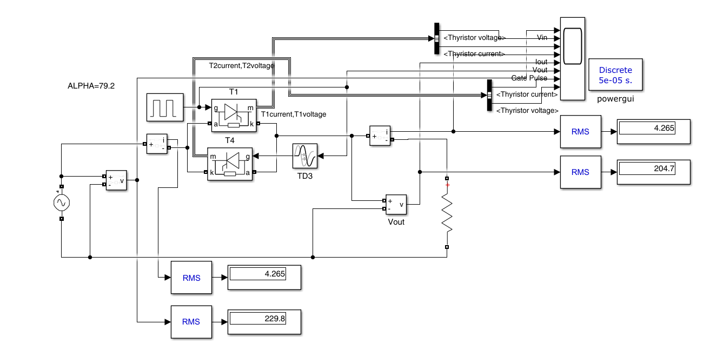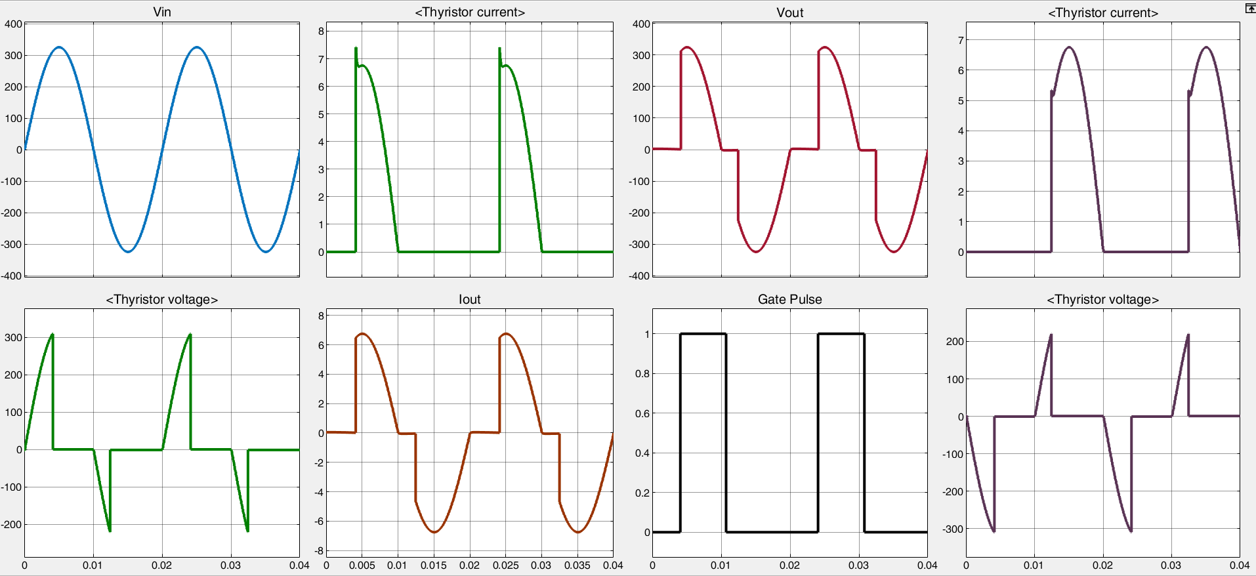
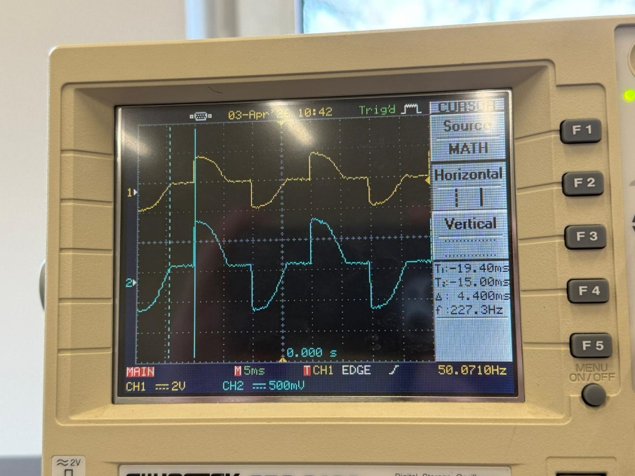

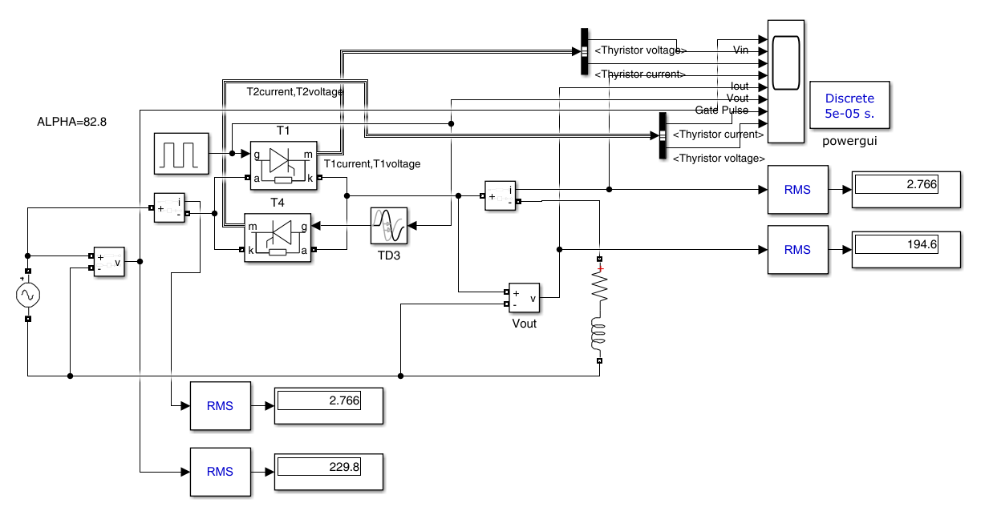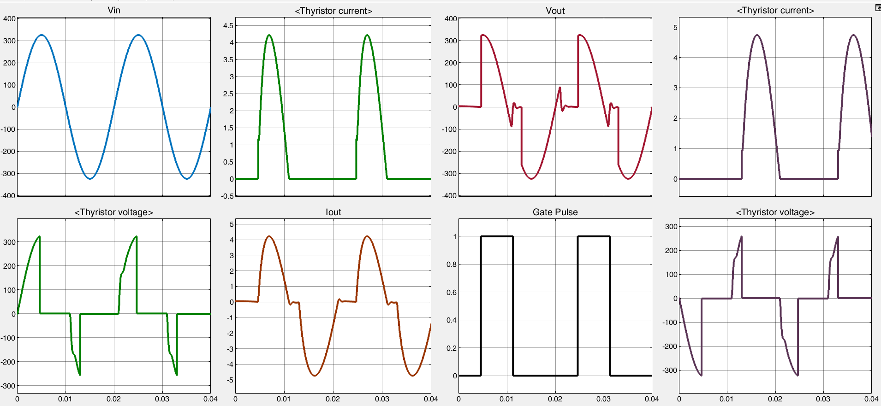
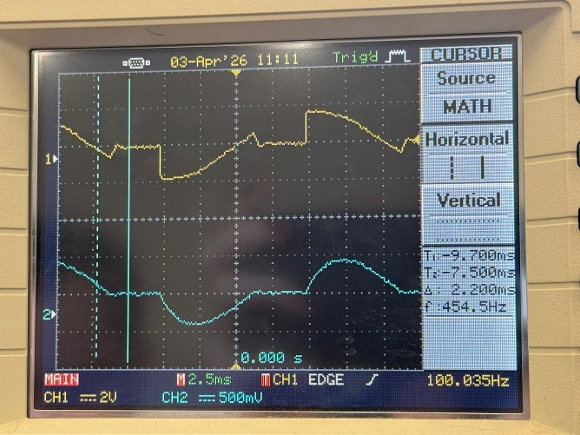

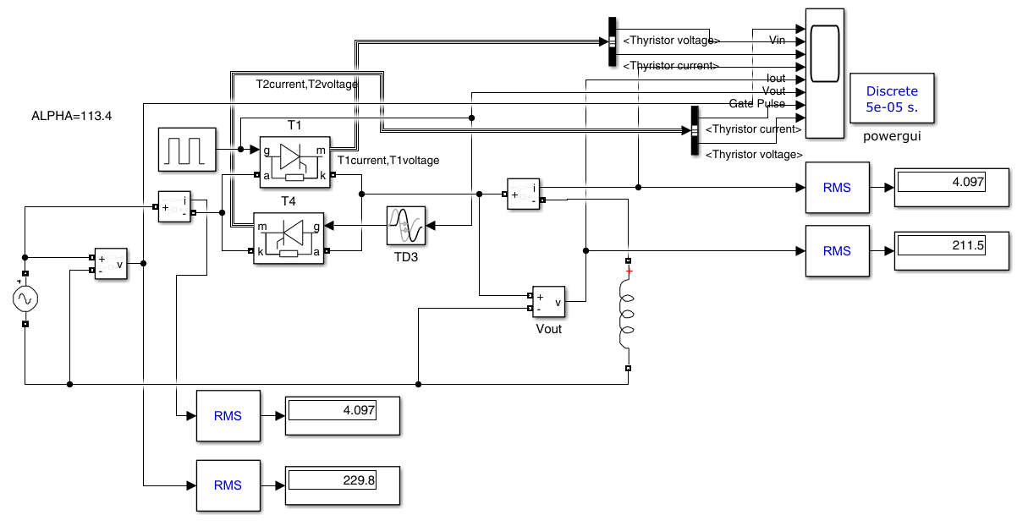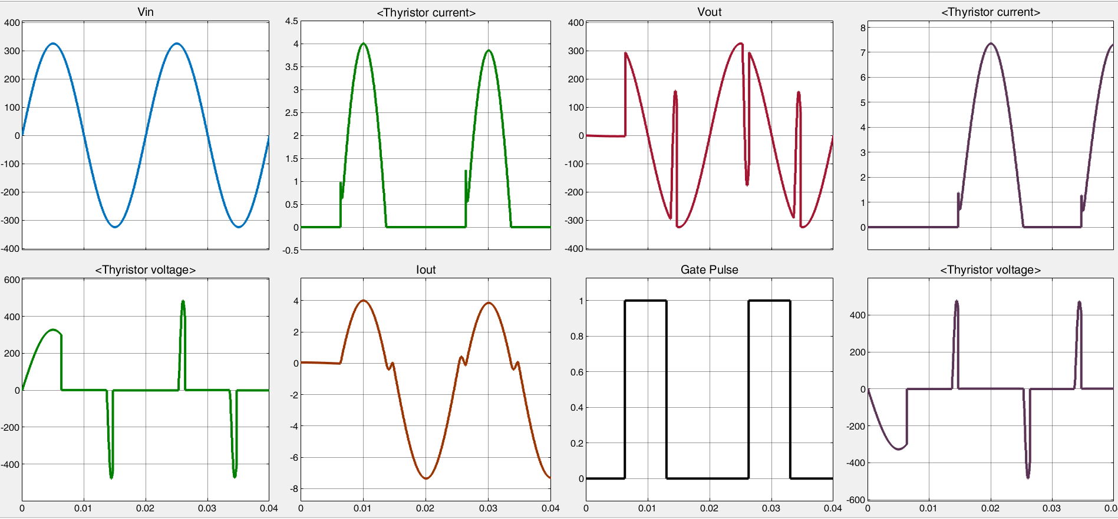
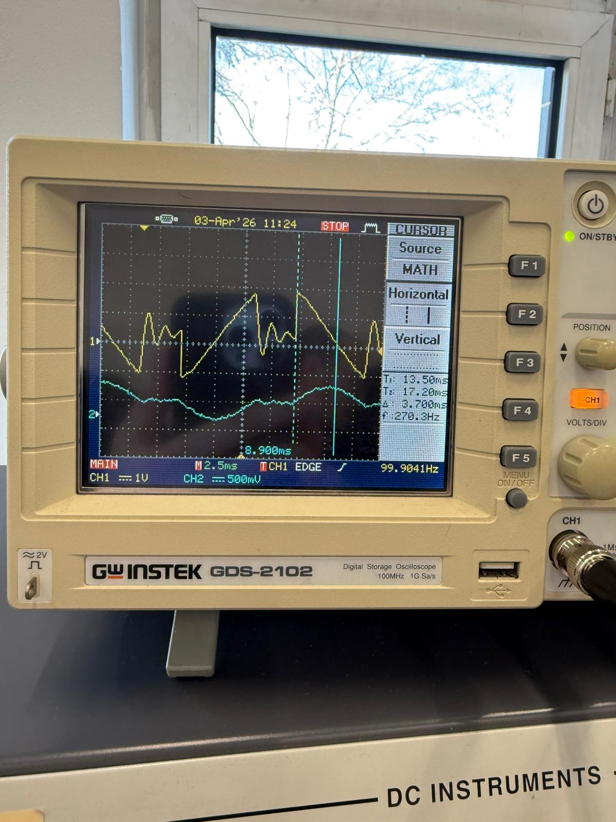

Load Type | Ry (Ω) | Ly (H) | α (degree) | β (degree) | Vy (V) | Iy (A) | Vout (V) | Iout (A)
R Loaded | 48 | - | 79,2 | - | 51,4 | 1,082 | 241,58 | 2,5968
RL Loaded | 64 | 0,061 | 82,8 | 207 | 23,52 | 0,595 | 110,544 | 1,428
L Loaded | - | 0,1525 | 113,4 | 230,4 | 39 | 0,433 | 183,3 | 1,0392

